SOUND SCIENCE: BASICS OF BIOACOUSTICS – SOUND MAP STUDENT WORKSHEET

1. What is a Sound Map?
A sound map is a simple way of noticing and documenting sounds in a local area by drawing or labelling them on a blank card or paper. Scientists use sound maps to visualize, analyze, and monitor environments by mapping acoustic data, often for ocean floor mapping, wildlife monitoring, and assessing human-induced noise levels.
2. Create Sound Maps
In this activity, you will create two sound maps. The idea is to sit quietly and concentrate for 3-4 minutes and record the sounds you hear. You can be as creative as you’d like, but there are a few requirements.
- Include yourself in the center of the sound map
- Write or draw the things making the sounds you hear (car, bird, person, etc.)
- Indicate through size, arrows, or distance from you (or another way), how loud/quiet and near/far the sound is
- Indicate if the sound is natural or man made
There are options depending on whether your class will stay indoors or venture outside.
Option 1:
- Create the first sound map in your classroom.
- Create the second sound map outside in an area approved by your teacher
Option 2:
- Create the first sound map in your classroom.
- Create the second map in your classroom using an audio of a natural environment played by your teacher. Record the sound from the audio on your sound map.

A few examples of a Sound Map are below.
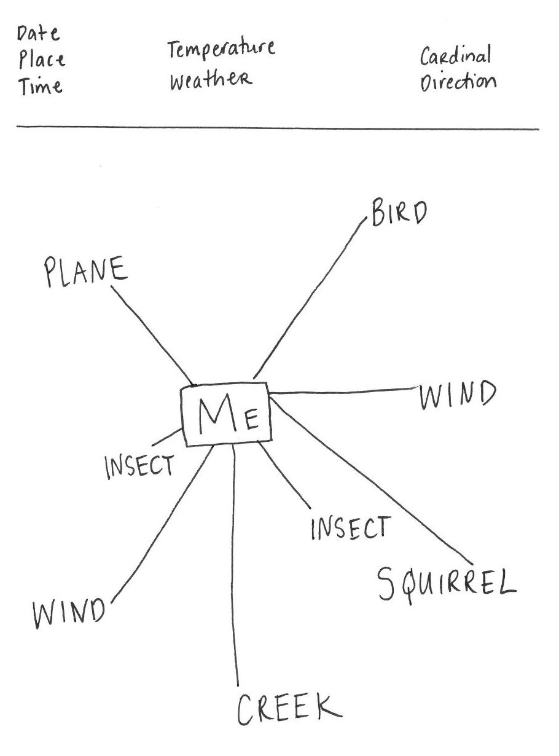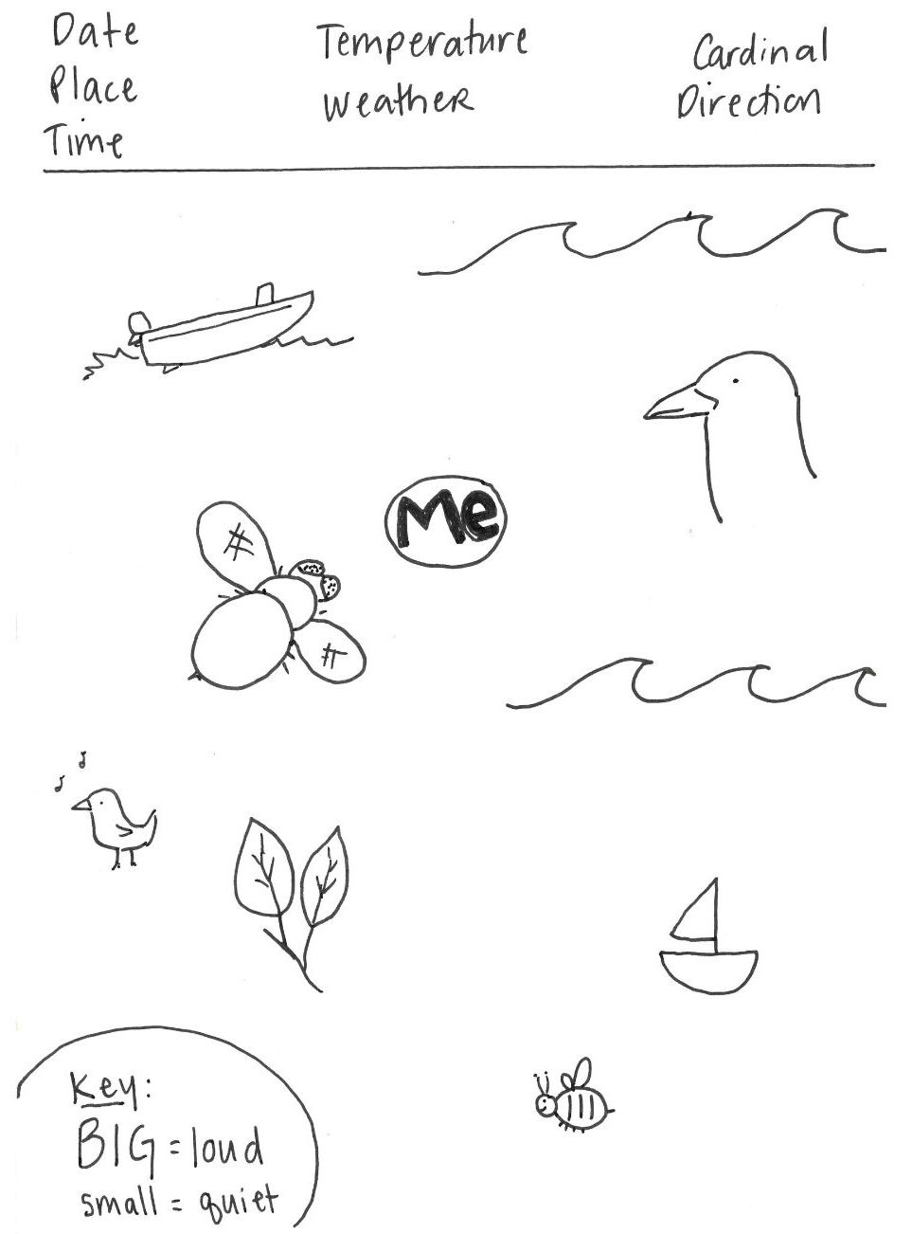

3. Reflect and Discuss
Complete the two sound maps and be prepared to share them in class. Take a moment to reflect on what you’ve created and be ready to discuss the following questions.
- How were your two sound maps different?
- What clues would tell you you’re in a different environment?
- Where did you hear more natural sounds? Why?
- Where did you hear more human-made sounds?
- Which environment was louder? quieter? more complex?
- What might these sound differences tell scientists about each place?

